# **DPS920/CVI620**

# **Project – Final Report Submission**

**This is a GROUP Submission, NOT an Individual Submission. ALL team members must submit the final work.**

***Please paste the resulting images, answers, … in this document.***

1. **Project Title.** What is the title of your project?

Maze Solver

1. What is the **problem** that you are trying to solve? (Please explain in a paragraph.)

A maze is a two-dimensional structure divided into rows and columns representing cells of equal size. All cells are filled with a wall and empty spaces that represent a possible path to the endpoint. Only two cells are known, one as a starting point and one as an endpoint. Only open squares of the maze can be passed through. If a wall is meet when trying to go through the maze, a different direction has to be taken. Using computer vision techniques to detect the walls of a maze, the goal is to make a computer program to solve a maze by implementing algorithms and techniques learnt from OpenCV. The program will use video capture as input and output the same maze with lines drawn to show the solution.

1. **Dataset.** What is the dataset you used? How many images/videos does this dataset have? Please paste a few images/snapshots here.

The dataset used in this project will be a video capture capturing a maze as input and also a picture of a maze. The images below represent the test data set. The first image was captured using video capture of a maze from a webcam. The second image is a generated picture of a maze.

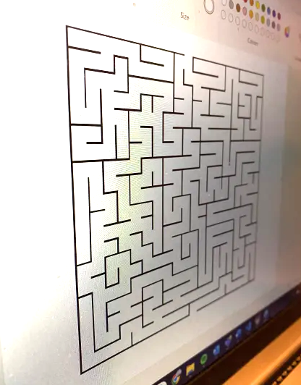



1. **Ground Truth.** If applicable, show samples of Ground Truth (gt) and how it was collected and/or labelled.
2. **Training vs Test vs Validation.**  Explain how you divided your dataset into training / test / and validation sets.
3. **Previous Works:** Explain what has been done by others and which one (if any) you are using (code or idea) as a starting point. You need to include all references at the end of this document. (Please explain in a paragraph.)
4. **Contribution and Method.** Briefly explain the method you used in this project to tackle the problem in Part 2. What are your contributions? What steps did you add to previous works? Why did you choose these steps? Detailed explanations for any team member must be included in individual reports. (Please explain in 2 paragraphs.)
5. Explain whether you achieved what you expected with this method? If yes, why, if no, why not. (Please explain in a paragraph.)
6. Evaluation.
   1. Please provide a performance evaluation of your method (quantitative and qualitative, if applicable). Note that you evaluate the method you proposed (Part 7) on the dataset you chose (Part 3) for the problem in part 2.
   2. Please provide sample results (qualitative and quantitative, if applicable).
   3. Comparison with previous works (Part 6) needs to be included in this part as well.
7. **Code submission**. Please submit your code and required files (or a link to a shared folder) and specify instructions on how to run your code.
8. **A list of references.** Please do ***NOT*** just include the link! Include the title, author, year, etc. See different citation styles such as APA, MLA, …: <https://pitt.libguides.com/citationhelp> For IEEE you can find more examples here: <http://libguides.murdoch.edu.au/IEEE/all>
9. Add this declaration to this report:

We, ------------ (mention assigned group number and your names), declare that the attached assignment is our own work in accordance with the Seneca Academic Policy. We have not copied any part of this assignment, manually or electronically, from any other source including web sites, unless specified as references. We have not distributed our work to other students.

1. Specify what each member has done towards the completion of this work:

|  | Name | Task(s) |
| --- | --- | --- |
| 1 | Kirk Parillon | 1,2,3 |
| 2 |  |  |
| 3 |  |  |

1. **Sharing and copyright (Optional).** Your project is a good addition to your resume. In addition, it is a good idea to share your work with others. If you wish, make a website, or GitHub page and share your work. Make sure everyone in the group is OK with this and acknowledge them all.

You can include the following on your site:

1. *Dataset*. If you captured images or videos yourselves.
2. *Ground Truth*. Did you gather ground truth data yourselves? Include the data.
3. *Training and Test*. Include your training.csv and test.csv.
4. If you used open source/ online code, please provide the links.
5. Your code as a starting point for other future projects.
6. Instructions to using your code. For example, what are the required software installations for your code to work? Which operating system? How to run your code? Include details.

Link to your site: _____________________________